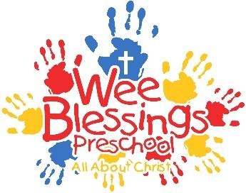

WEE BLESSINGS PRESCHOOL
AUTHORIZATION AGREEMENT FOR AUTOMATIC PAYMENT

I (we) hereby authorize Iowa State Bank to initiate debit entries to my (our) account.

FINANCIAL INSTITUTION _________________________________________________________
FINANCIAL INSTITUTION ABA# ____________________________________________________
NAME(S) ON ACCOUNT _________________________________________________________
CITY _____________________ STATE _______ ZIP _______________
[ ] CHECKING ACCOUNT NUMBER ___________________

By signing this form, I (we) authorize Iowa State Bank to withdraw my monthly tuition payment for Wee Blessings Preschool.

_________________________ _________________________ _______________
Signature Signature Date

The authority you have given both the depository and us will remain in effect for the 2021-2022 school year. You have the right to stop payment of any withdrawal by notifying the depository before it has charged to your account. After your account has been charged, you may have the amount of any withdrawal made in error immediately corrected by the depository up to 15 days following notification or 45 days after posting, whichever occurs first.

**PLEASE ATTACH A VOIDED CHECK VERIFYING THE FINANCIAL INSTITUTION ABA NUMBER AND ACCOUNT NUMBER **

